To create a SASS project:

Once sass and compass are installed successfully,

1. Create a new folder to save your project (say ‘Test Project’ in D drive)
2. From the path D:/Text Project in the command prompt, issue the command ‘compass create’
3. This shall create some default folders like ‘stylesheets’ and ‘sass’ with a config.rb file.
4. Delete all the default files created under folders sass and stylesheets folder under ‘Test Project ‘ folder.

Now we are all set to create our own SASS structure.

1. Create folders ‘base’ and ‘modules’ under D:/test Project/sass folder
2. Create a file called ‘main.scss’ under D:/test Project/sass folder
3. Add a file called ‘_buttons’scss’ under modules folder.
4. Add a file called ‘_variables.scss’ under ‘base’ folder.
5. Declare some variable in _variable.scss file, say

$btn-bg-color: #cccccc;

1. Now, lets us add some class under _buttons.scss file.

Eg:

.button-class{

background-color:$btn-bg-color

color: #000000;

border-radius: 3px;

border: 1px solid #cccccc;

}

1. Now import the sass files in main.scss file. Open main.scss file add following lines

@import ‘base/_variables.scss’

@import ‘modules/_buttons.scss’

1. Go to the command prompt where you issues the compass create command.
2. And issue the command , ‘compass watch’ (This command has to be issued from the path where your config.rb exists)
3. If everything is working fine, then you should be able to see compiled main.css file under stylesheets folder.

Try create an html file and refer this css file in your html file.

**Assignment 1:**

Write SASS structure for an input control with following specifiations:

**Normal Input specs:**

Border radius: 3px;

Width:300px;

height:36px;

//border:1px solid #ccc;

font-style:SegoUI

font size:13px

padding-left:10px

color:#666666

background-color:#ffffff;

**Input control when Disabled:**

//Border: 1px solid #cccccc;

background-clor:#eeeeee;

colro:#999999;

cursor: not-allowed;

**Input control when error:**

Background - color:#fde7e1

border:1px solid #f44336

color:#f44336

**Assignment 2:**

**Button control specifications:**

We need to create primary and secondary button styles, where following are the properties in common.

Border Radius: 3px;

padding: 12px 15px 12px 15px;

Background color: #8bc34a;

border: 0;

min-width: 110px;

font-family: "SegoeUI SemiBold";

font-size: 16px;

color: #FFFFFF;

**Primary button shall have following specifications:**

Background Color: #8bc34a;

Color: #FFFFFF;

Border: 1px solid #8bc34a;

**Primary button on Hover shall have following classes:**

background-color: #9dce5d;

color: #FFFFFF;

border: 1px solid #9dce5d;

**Primary button when disabled shall have following classes:**

background-color: #eeeeee;

color: #999999;

border: 1px solid #eeeeee;

**Secondary Button shall have following classes in addition to base properties:**

background-color: #FFFFFF;

color: #2095f2;

border: 1px solid #2095f2;

**Secondary button on hover shall have following classes:**

background-color: #2095f2;

color: #FFFFFF;

border: 1px solid #2095f2;

**Secondary button when disabled shall have following classes:**

background-color: #ffffff;

color: #999999;

border: 1px solid #cccccc;

use the compiled CSS generated in an sample html and sample page shall look like below and shall have all added effects on the control (effect on hover, disabled etc)

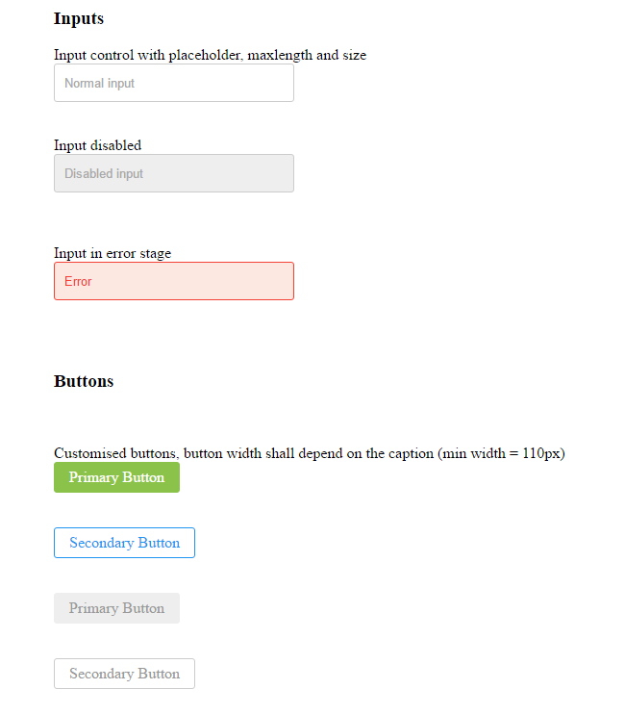

Hints:

1. Use variables wherever you can.
2. Identify the common variables and move them to _variables.scss
3. Write mixins for border radius and add a file called _mixins.scss under base folder
4. Do not forget to import this file before using in main.scss file
5. Use inheritance wherever possible.
6. Variables which are not used across files can be kept in the module file (like _buttons.scss) itself.
7. For writing input control related SCSS, add another file called _inputs.scss file under modules.